|  |  |  |
| --- | --- | --- |
| **Number** | **Component Name** | **Component Function** |
| 1 | Arduino Uno | The Arduino Uno is a microcontroller board based on the ATmega328. |
| 2 | Breadboard | A breadboard is a solderless device for temporary prototype with electronics and test circuit designs. |
| 3 | ATmega328P | The ATmega328 is a single-chip microcontroller that execute the program loaded into it. |
| 4 | Resistor | A resistor is a passive two-terminal electrical component that implements electrical resistance as a circuit element and flow of current to other components. |
| 5 | NTC 10k Ω Thermistor | A thermistor is a type of resistor whose resistance is dependent on temperature, more so than in standard resistors. |
| 6 | USB Type B | The port allows a connection between the Arduino Uno and computer. |
| 7 | LEDs | A light-emitting diode is a semiconductor light source that emits light when current flows through it. |

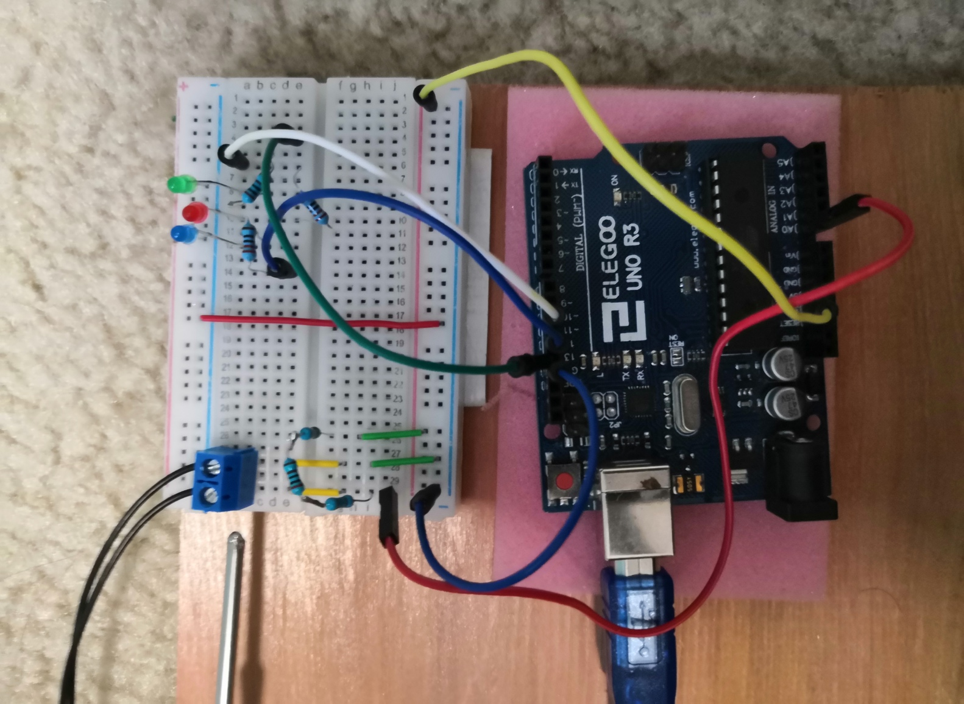

2

4

6

3

5

1

4

7

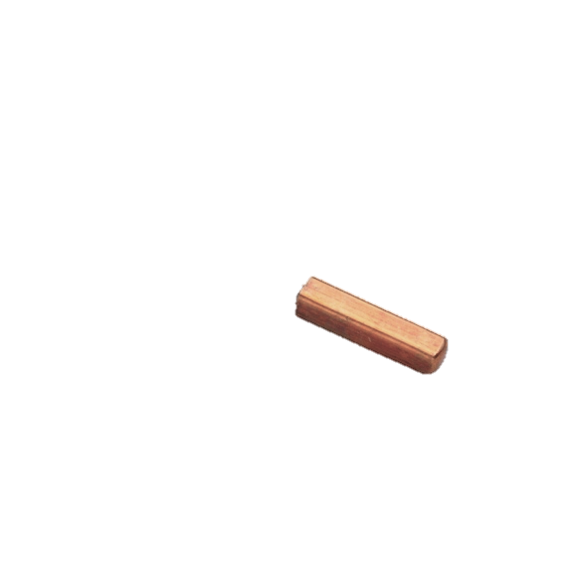

**Device Construction:**

The device was construed using an Arduino Uno, along with multiple resistor, a NTC thermistor, and a breadboard. A 5-volt wire connects to the breadboard where it passes through a 5793 Ω which created a voltage divider. The thermistor outputs an altered voltage to the analog input on the Arduino. Based on the output of the thermistor, the Arduino sends a voltage to the red, blue, and/or green LEDs.

**Waterproofing of Thermistor:**

The thermistor was waterproofed via a cheap R/C antenna tip, liquid electrical tape, epoxy, and rubber shrink tubing. The antenna tip was cleaned out via acetone, the cartridge was then filled with liquid electrical tape to half-way. The thermistor was then inserted into the liquid electrical tape filled antenna tip, then the rest was filled with epoxy to ensure no water could enter the antenna tip. Multiple layers of heat-shrink tubing was then placed over the top of the antenna tip and the wire leads to ensure no water could touch the soldered leads.

**Equation:**

where…

T = temperate (C)

v = voltage (volts)

A, B, C are coefficients

**Solving for Coefficients:**

A = 0. 0009648056479403602

B = 0. 00026431933444130115

C = -0.00000006600723354780666